CORAL REEFS

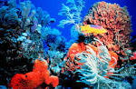

By
Jamie
Mc Grath

What is a coral reef?

- A coral reef is an underwater structure made from living organisms.

- Coral reefs are groups of tiny animals, plants and fish.

- Most coral reefs are built by stony coral.

- Reefs grow best in warm, shallow, clear, sunny and wavy waters.

- Wavy waters bring food, nutrients and oxygen to the reef. Waves prevent sediment from falling on the reef.

- A coral reef is an underwater garden.

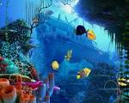

The three main types of reef are:

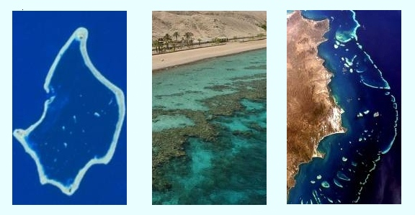
Atoll Reef Fringing Reef Coral Reef

Fringing reef – directly attached to a shore, or borders it with a shallow lagoon – found in Hawaii

Barrier reef – reef separated from the mainland by a deep lagoon – found in Australia

Atoll reef - a continuous barrier reef extends all the way around a lagoon without a central island – Pacific Islands

What can be found in a Coral Reef?

- Many species of Whales, dolphins and porpoises
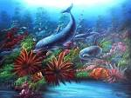

- 1500 species of fish, eg: clown fish, snapper and many types of trout.
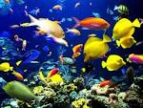
- 17 species of sea snake.
- 6 species of sea turtle, eg: green or leatherback turtles.

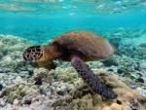
- Many saltwater crocodiles live in the warm waters, close to the reef
- 125 species of shark and stingrays
- 5 million species of mollusk, including giant clams and cone snails.
- Sea grasses are especially important because they provide shelter for young reef animals like lobster.
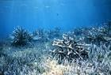

Factors affecting the reefs/ Environmental threats

- The climate – weather conditions

- Pollution / water quality

- Other fish disrupts food chains

- Fishing – anchors, nets and baits

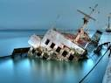

- Shipping accidents

- Human – scuba divers and swimming

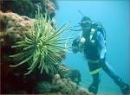

- Fishing

The most famous Reef - The Great Barrier Reef

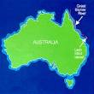

- The Great Barrier Reef is the world’s largest Coral Reef.

- It’s located off the coast of Queensland, Australia.

- It’s made up of 2900 individual reefs.

- It’s approx 1200 miles long

- It can be seen from outer space.

- It’s the largest single structure made by living organisms known as “coral polyps”.

- It became a world heritage site in 1981.

- It’s one of the Seven Wonders of the World.

- It’s approx 20,000 years old.

Class Questions

- What is a Coral Reef?

- What do Coral Reefs need to survive?

- What are the 3 main types of reefs?

- The Great Barrier Reef, is located where?

- Name 3 factors that affect a coral reef?

Class Answers

It’s an underwater structure made from living organisms.

Sunlight and warm water

3.
Atoll, Barrier and Fringing

4.
Queensland, Australia

5.
Pollution
Fishing
Scuba Diving
Fishing Accidents
Weather
Other fish
Fishing Accidents
Weather
Other fish

